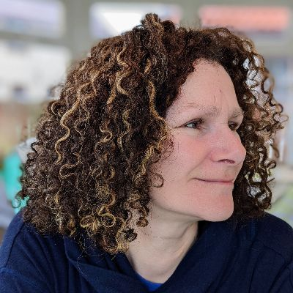

Dear Friends,
I am delighted to have joined the College as Principal at the beginning of this year, and I have been warmly welcomed into the Cuddesdon community. I’ve been met with real generosity of spirit, good humour, and depth of thought. I would like to extend some of that same warm hospitality and profundity to alumni and friends by inviting you to take part in the events, retreats, courses, and study opportunities on offer, that alongside our student body make this such a diverse and vibrant place of learning.
It is my great pleasure to invite you to this year’s Friends and Former Members’ Day on Friday, 22 May. I very much hope to meet many alumni and others connected with the College on that occasion. Please do save the date — further details of the programme will follow shortly.
There will also be several Open Days in the coming months. If you are discerning a call to ministry yourself, or know someone who is, our Open Days are a well-tailored and welcoming opportunity to explore whether Cuddesdon might be the right place to undertake training. I warmly encourage you to visit, or to encourage others to do so. The dates are listed below.
I feel particularly fortunate to have joined the College at a time of growth and new opportunity. In partnership with Chelmsford Diocese, we are preparing to launch the Cuddesdon Chelmsford Centre for ordination and lay ministry training this September, extending our provision to a wider geographical area.
We have a number of full bursaries available for students joining us this year in our new range of courses in Mission and Ministry with Children, Young People and Families. These programmes are designed for both volunteers and paid workers engaged in this vital field of ministry.
Please do be in touch if you have any questions about what you read here, or if you would like to also receive our Vocations Newsletter. I would be very glad to hear from you at Principal@rcc.ac.uk. I look forward to connecting with you and to leading Cuddesdon forward during the time in which I am privileged to serve as its Principal.
With every good wish,
Revd Dr Harriet Harris MBE
Principal


Children's and Youth Ministry in the Sacramental Tradition
26 March 2026, 10am–3.30pm
There is much effective children's and youth ministry and mission developing in sacramental traditions within the Church of England. This day will aim to celebrate what is happening to explore models of good practice, facilitate relationships and networks, and generate conversation about future development. Come and hear examples of good practice and join the conversation:

Compassionate Leadership Training : exploring the power of Compassion in leadership, organisations and society - 5 May 2026, 10.30am–4pm
Grounded in current research, this day will explore evidence-based ways in which Compassion makes a measurable difference personally, organisationally and societally.
You will gain insights from social neuroscience and organisational psychology into why and how Compassion can improve personal, institutional and social wellbeing in your own settings; realistic compassion practices that you can apply to yourselves and your team; and explore the common concerns that compassion is somehow unprofessional and time-consuming.
The day will be facilitated by Revd Dr Harriet Harris who has led Compassion and Compassionate Leadership work across government, healthcare, education and ministry.

RETREAT PROGRAMME
Praying with the Poets
3 - 5 June 2026
In this contemplative and creative retreat, poet and priest Esther Lay will offer a programme of prayer, reading, discussion and creative writing.
The Poetry of Pilgrimage
7 - 9 October 2026
Michael Mitten will draw on his encounters of leading pilgrimages to early Christian sites and the stories of faith associated with them, to give insights that can strengthen and enrich our daily pilgrimage with God.
So Who Am I Now? Transition from Ministry to Retirement
14 - 16 October 2026
A retreat for those approaching retirement or newly retired from full-time ministry, to explore the transition from work-based ministry to retirement ministry.
The first few years as a first time incumbent
4 - 6 November 2026
A retreat for those in their first few years of first incumbency to explore the transition from curacy to incumbency.

Open Days
Our Open Day dates for full-time, context-based and part-time training are on:
- Saturday, 25 April 2026
Saturday, 7th November 2026

