9 April 2019

Dear Applicant

Chef Manager

Thank you for your interest in a post at Ripon College Cuddesdon.

Ripon College Cuddesdon is a leading Anglican theological college in the UK, training around 120 men and women for ordination in the Anglican Church through a range of residential and non-residential courses. Established in 1854 with a long history of past students holding the highest offices in the Church of England, the College has constantly been at the forefront of theological education. It remains today a contemporary, confident and thriving place of learning, as well as being a vibrant and stimulating community in which to live and work.

At this time we are looking to recruit an experienced chef with a focus on good quality provision, high standards and effective organisation to lead the College’s Catering Team. The Chef Manager is responsible for the day-to-day running of the kitchen, managing the team to achieve outstanding customer service, overseeing quality, creating menus and achieve excellent standards of health and safety and food safety.
Please find attached the:
- Job descriptions and person specification for the posts
- Application form
- Equal opportunities policy and form – please complete and return the form with your application

If you would like to be considered for the position please complete the application form, within which you should set out your reasons for applying for the role and demonstrating how your aptitudes, enthusiasms, experience and qualifications match with the Job Description and Person Specification.

Your completed application form should be sent to: Michael Hunt. Bursar, Ripon College Cuddesdon, Oxford OX44 9EX (michael.hunt@rcc.ac.uk) to arrive not later than Friday 3rd May 2019. Interviews will be held at Cuddesdon in the week commencing 6th May 2019.

Yours sincerely,
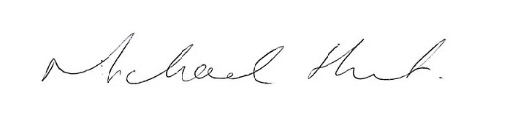
Michael Hunt
Bursar

