
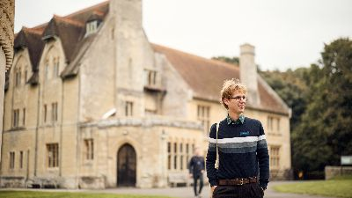

Dear friends,

This Newsletter comes with our continuing thanks, and to promise our prayers for you, as our alumni, friends and supporters, in your several ministries and settings at the start of a new academic year. It will be an exciting year for Cuddesdon (and a sad one for me, personally) as I retire and move on in December. But I am delighted that the Governors have made such a confident and exciting appointment in the shape of the Revd Dr Harriet Harris, who takes over as Principal in January. I wish Harriet well in one of the most rewarding and engaging jobs in the entire Church of England!

Apart from this change, Cuddesdon will be continuing in the coming year to evolve its own understanding of its priorities and resources as a leading centre of learning and formation for ministry in the Church of England, responsive to the Church’s needs and creative in our contribution to the Church’s mission and ministry in stirring and changing times. The sector in which we operate – like the wider Church, itself – is facing challenges in a range of contexts and forms. Imagination… courage… adaptability… wisdom… above all, faithfulness to the Faithful One – these are the graces for which we ask your prayers in our ongoing life and work. They are also the qualities and habits that, by the grace of God, we aim to see formed in our students and reflected in our corporate life.

So I make so bold as to ask for your continuing prayers and support. In particular, I ask you to encourage all those in your care to reflect deeply on the vocation God has for them. Cuddesdon stands by to offer support for those for whom that calling may be to authorised ministry (ordained or lay) – it is also a place to which many resort as retreatants, independent students, conference guests or simply pilgrim visitors. We would love to welcome you in any or all of those capacities!
With all blessings and good wishes,

Bishop Humphrey Southern
Principal

Join us on Wednesday, 3 December, for a farewell celebration honouring Bishop Humphrey's retirement as Principal after more than 10 years of dedicated leadership at Cuddesdon. The event begins at 11am with refreshments in the Common Room, followed by a Celebration Eucharist at 11.45am, and concludes with a Buffet Lunch.
Please RSVP to sophie.farrant@rcc.ac.uk

THE ELIZABETH PATHWAY

We are excited to announce a new partnership with the Diocese of St Edmundsbury and Ipswich to offer the Elizabeth Pathway for the first time. This two-year pathway is intended for older people who already have significant experience of lay ministry. With weekly study and formation based in the diocese, and three weekends spent at Cuddesdon each year, students benefit from a range of expertise in both locations.
This bespoke pathway has been designed specifically to prepare students for ordained assistant ministry in their local diocese. During their first year of study and formation, students go through the Church of England ordination discernment process. If they are sponsored for ordination, they then continue onto their second year. At the end of two years, students complete their studies and become ordained.

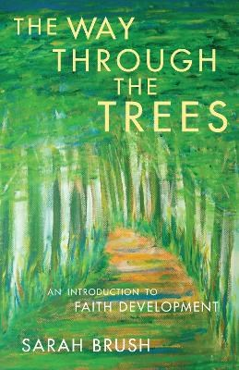

BOOK LAUNCH

Join us for the book launch of 'The Way Through the Trees' by Revd Dr Sarah Brush, Vice-Principal, on Friday, 14 November from 3pm - 5.30pm in the Common Room at Cuddesdon. Dr Brush presents a case for the concept of development in faith through engagement with scripture, the Christian Tradition and modern theology.
Come and meet the author and buy a signed copy - all welcome.

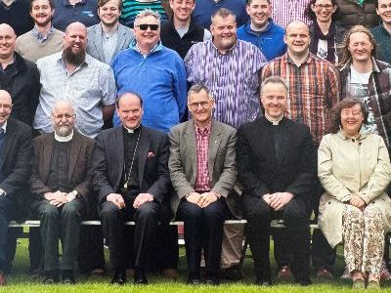
ARCHIVE OF COLLEGE PHOTOGRAPHS

Gillman & Soame have been the College's official photographers for at least half a century. They have now created an online gallery of College Photographs dating back to 2004 which are available for viewing and purchase. Please use the link and enter your email address to access and order directly from Gillman & Soame: https://www.gsimagebank.co.uk/rcc/login/?token=alumniiuv7hv

Ripon College Cuddesdon
Oxford OX44 9EX

www.rcc.ac.uk

