SPEAKERS

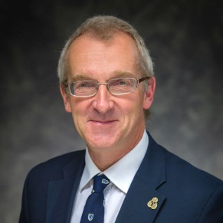
Professor Tom McLeish is Professor of Physics at Durham University is also chair of the Royal Society’s education committee. After a first degree in physics and PhD in polymer physics at Cambridge University, a lectureship at Sheffield University in complex fluid physics, lead to a chair at Leeds University from 1993. He has published over 180 scientific papers and reviews, and is regularly involved in science-communication with the public, including lectures and workshops on science and faith. In 2014 OUP published his book Faith and Wisdom in Science. He has been a Reader in the Anglican Church since 1993, in the dioceses of Ripon and York.
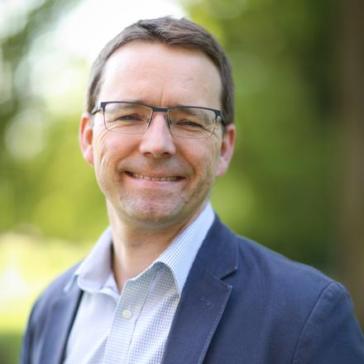
Dr Hywel Clifford is Lecturer in Old Testament at Cuddesdon. He studied divinity at Edinburgh University where he majored in Biblical Studies before a master's degree in Old Testament, and a doctorate at Christ Church, Oxford. Hywel’s areas of interest include monotheism, early Greek philosophy, the thought of Philo of Alexandria, the history of Biblical Interpretation, and the archaeology of biblical lands.

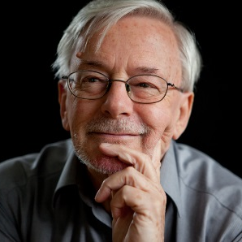
The Revd Canon Professor Keith Ward is Regius Professor of Divinity Emeritus at Christ Church Oxford. His degrees are a BA (Wales), B. Litt. (Oxford), MA (Cantab) MA (Oxon), DD (Cantab), DD (Oxon.). Keith has published widely in philosophy and theology, and his specialist research interests are in Religion and Science, Ethics, Comparative Religion and Theology. His latest publications are 'The Christian Idea of God' (CUP, 2017) and Christ and the Cosmos (CUP, 2015).

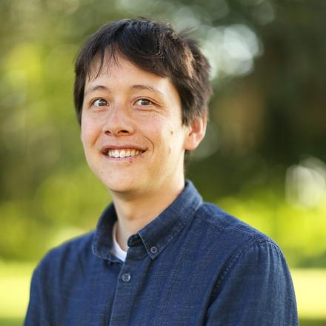
Dr Tobias Tanton teaches Christian Doctrine at Cuddesdon, and has a particular research interest the interaction between theology and contemporary developments in cognitive science. Originally from Australia, he completed degrees in Commerce, Information Technology, and Classics at The Australian National University, and a Bachelor of Theology at St Mark’s National Theological Centre in Canberra. He moved to Oxford for graduate studies, reading for an MPhil in Theology at Harris Manchester College and a DPhil in Theology at Exeter College.

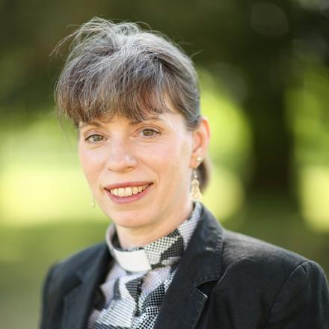
Revd Jen Brown is the director of the Cuddesdon School of Theology and Ministry and Science Missioner in the Churn Benefice in South Oxfordshire. She has degrees in psychology and the psychology of religion. She has a particular interest in the ways in which religious practice shapes beliefs and behaviour and is currently pursuing a PhD in this area. Her other interests include liturgy, Christianity and the arts, social justice, the environment, and Christian theology and animal welfare.

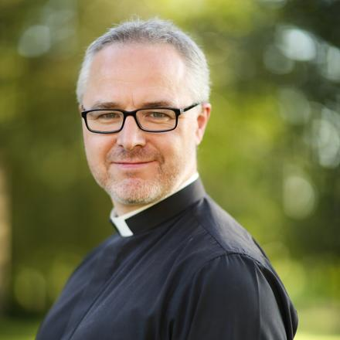
Revd Dr Michael Lakey divides his time between teaching New Testament at Cuddesdon and being a parish priest of three parishes in South Oxfordshire. Michael completed Bachelors studies in Theology and Mathematics at Chester, Masters work in Applied Theology at Chester, and a PhD in New Testament at Durham. His ongoing research interests include St Paul, sex and gender in Antiquity, and the hermeneutical relationship between Scripture, doctrine, and liturgy.

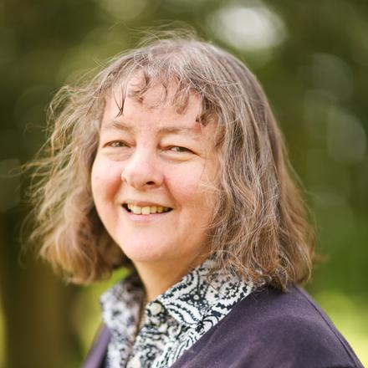
Revd Dr Joanna Collicutt is Lecturer in Psychology and Spirituality at Cuddesdon as well as the Oxford Diocesan Advisor for Spiritual Care for Older People. She studied experimental psychology and theology at Oxford University, and clinical psychology at the Institute of Psychiatry, University of London. She is a chartered clinical psychologist and specialist neuropsychologist, registered as a practitioner with the Health Professions Council.

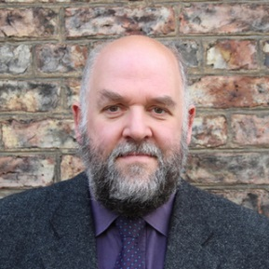
Revd Dr Peter Phillips is Director of the CODEC Research Centre at Durham University. A Methodist Minister and former Faith and Order Secretary for the Methodist Church, he is now a full-time academic researching Digital Theology. His research explores amongst other things, Bible engagement in the digital age; Theology within the wider field of Digital Humanities; and the role of science fiction in our theological exploration of human identity, transhumanism, AI and theological reflection.

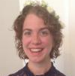
Jaime Wright is a doctoral candidate at the University of Edinburgh, studying the intersection of science, religion, and literary works. Her publications include 'Emily Dickinson: A Poet at the Limits' (Theology in Scotland, 2017) and 'In the Beginning: The Role of Myth in Relating Religion, Brain Science, and Mental Well-Being' (Zygon, 2018). Jaime is also an ordinand in the Scottish Episcopal Church.

FRIENDS AND FORMER MEMBERS' DAY

Summer School attendees have the option to join in with the College's annual Friends and Former Members Day or to have free time.

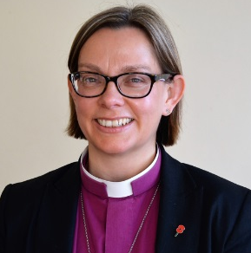
The Rt Revd Helen-Ann Hartley has been Bishop of Ripon since February 2018, and was previously Bishop of Waikato in New Zealand since 2014. Before this, Helen-Ann was the Director of Biblical Studies and a lecturer in the New Testament at Cuddesdon, and earlier trained for ordination on Cuddesdon's Part-Time Pathway. Helen-Ann is returning to her former College to preach at the Eucharist on the annual Friends and Former Members Day.

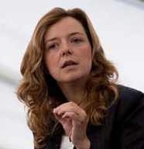
Dr Paula Gooder is a speaker and writer on the Bible, particularly on the New Testament. She began her working life teaching for twelve years in ministerial formation first at Cuddesdon, and then at the Queen’s Foundation for Ecumenical Theological Education in Birmingham. Following this she has been a speaker and writer in biblical studies, Theologian in Residence for the Bible Society, Director of Mission Learning and Development for Birmingham Diocese. Paula has a strong vocation to lay ministry and is a Reader in the Church of England.

