Don’t’ ask us to be productive, support us to be fruitful

Growing up, I lived in a house called Appletrees. The trees in our garden yielded far more apples than we could eat or give to others. I was one of five siblings, and we were sent to pick ten windfalls each day after school before we could come in for tea. At weekends we’d wrap the surplus apples individually in newspaper and store them in cardboard boxes to be turned into stewed apple, apple pie, Eve’s pudding or baked apple. We were overrun by apples and the industry of managing them, and thankfully the trees bore fruit only in season.

Imagine if the trees had been forced to produce apples non-stop. We can make nature do such things for us – turning dairy cows into continual milk-producing machines, for example. We can treat ourselves this way too, expecting endless productivity. Productivity is an aspiration of the industrial revolution. We make machines that can keep on going when humans would have to stop. But mechanism then becomes the ideal, and we expect farm-animals, plants, and human beings to be productive like machines.
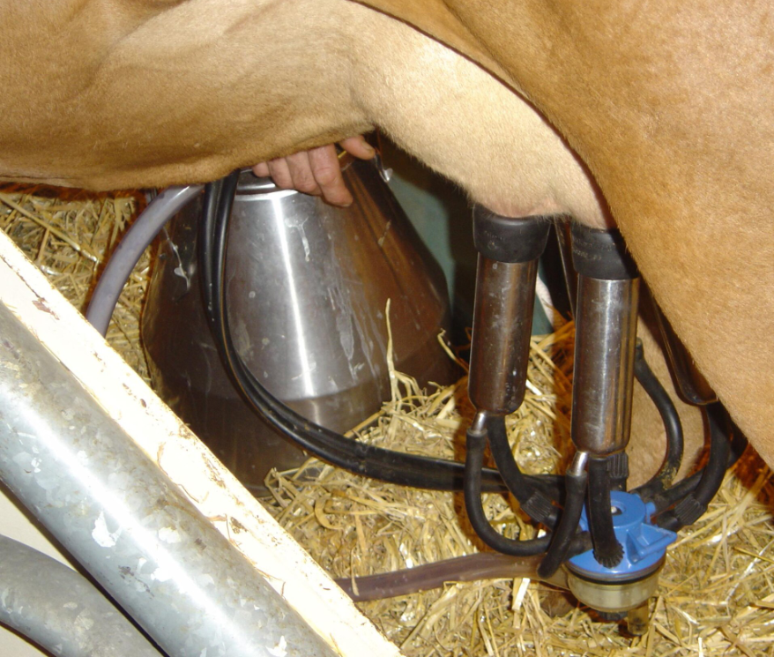
Copyright © 2004 David Monniaux, Creative Commons Attribution-Share Alike 2.0 France

I have been speaking with two students recently: one whilst he was considering applying for a university programme, another who has just started her MSc. I will call them Adi and Seonaidh (not their real names).
Adi is becoming increasingly anxious because he feels his brain has stopped working just when he needs it to make big decisions, write an impressive application, and be fit for interviews if he gets that far. He knows to give his brain a rest, but says that when he stops working he needs to stay ‘productive’ (his word). He means that he needs to read a novel that will improve him, or go for a run that will keep him fit and get oxygen to his brain, or play his guitar because music is also good for self-development, or watch Netflix but it should be something ‘worthy’.
Seonaidh is concerned because she has been ‘productive’ (her word) for two weeks, and suddenly cannot make that happen anymore. She has gone from feeling really stimulated by the course-material and by meeting new people - taking her laptop around with her and stopping to type up ideas when they occur to her - to feeling as though her brain has atrophied and she cannot concentrate on anything.

So we talked about trees. Adi has been in a situation of continuous assessment, being constantly high-octane because every piece of work he produces ‘counts’. He has been like an apple tree forced to produce apples non-stop for 18 months.

I asked Adi what a wise gardener would do for that tree. He didn’t know much about gardening, but he got the point. He moved his guitar downstairs so that he got a break from his own room. He walked in the wind and rain and felt the full power of nature with all his five senses, and he read for fun (a comic instead of Nietszche), with a huge bowl of snacks beside him, luxuriating.
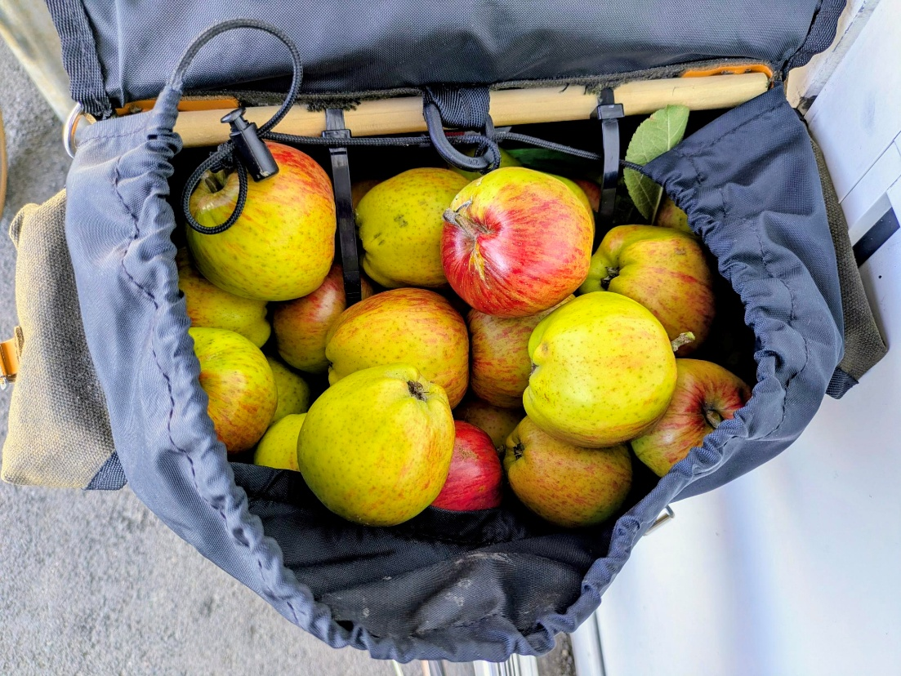
Collecting apples on a bike ride

Seonaidh has been blossoming, in the newness of her course and surroundings. She did not realise that blossom cannot continue forever. Trees have to let go of their blossom if they are later to yield fruit.

So, Seonaidh decided to let go. She left her books and bag in my room and went off with her packed lunch to walk around Arthur’s Seat. She came back saying she’d had the most amazing day. She looked alive and full of joy.

The academic year starts in the late summer and the turn towards autumn. The trees are heavy with fruit, which they need to let go. They will soon shed their leaves too, and be bare. What a fitting way to be open to all the new learning, to allow ourselves a beginner’s mind.

The winter is dark and cold, and it looks as though nothing is happening in these months, to the trees. They have no output that we can see. They are not producing. But it is all happening deep inside and underground, out of sight. Do not ask them to fruit in this season. This would be destructive. The roots are doing invaluable work in restoration and growth. Allow ourselves this time, respond fittingly to the dark and cold. This is not wasted time, it is time for deep thought, penetrating and rich. This is not the time for show; it is time for inner growth and wisdom.

The ground cracks and that is quite painful, and may feel alarming, but through the cracks come the first shoots of new plants. Spring is coming and the trees start to leaf. Branches that felt dead and heavy, stretch and experiment with life again.
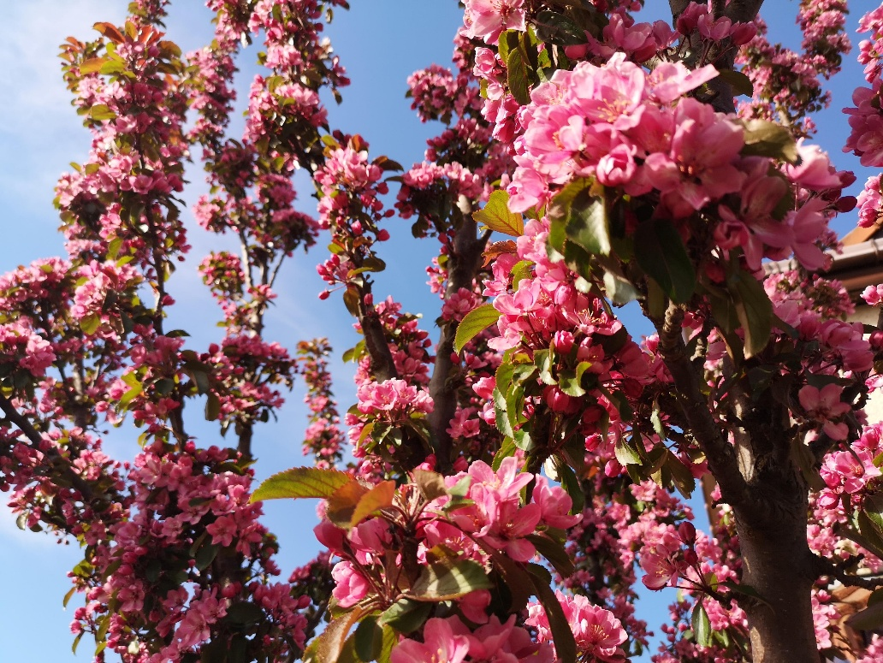
Apple blossom

Then come the buds and blossoms, the presentations and essays showing what we can do.

The fruit: well that comes in late summer. It may be a dissertation, or it may the fruit we experience after graduation, perhaps years after (!): the ripe yield from a mature tree.

Trust the seasons: rest, germinate, blossom, be fruitful, and let go.
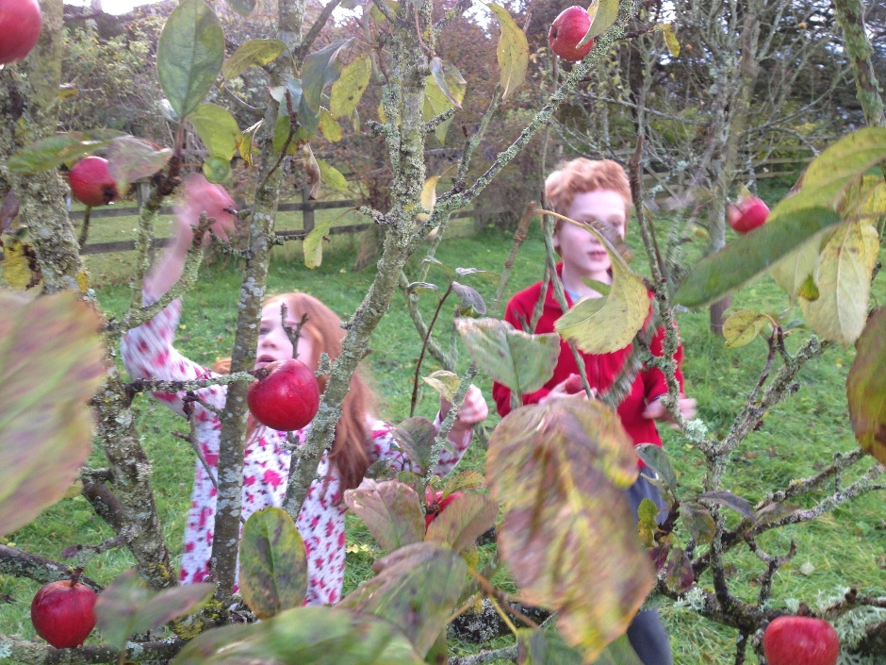
Playing amongst the apple trees

Blog by Harriet Harris
Principal, Ripon College Cuddesdon
For Masters and PGR Spa, and all looking for refreshment for their life and work

