VOCATIONS NEWSLETTER October 2022

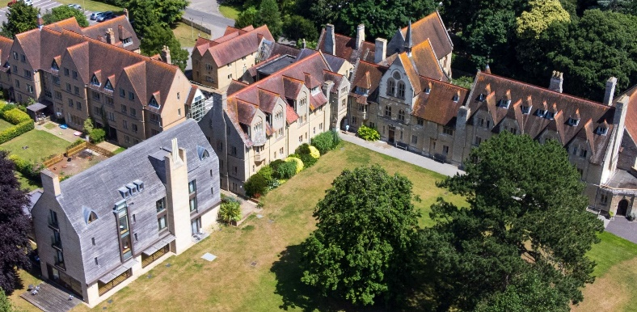
Welcome to our Vocations Newsletter for DDOs, ADDOs, Vocations Advisors and others working with ordinands and ministerial students. Our purpose is to give you updates on aspects of our courses and activities that we hope will be of interest to you. Please share this information with colleagues, people in the discernment process, potential independent students and any others who may be interested.
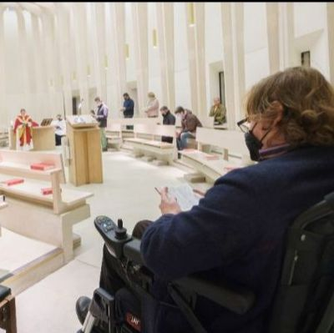
Accessibility: We welcome students with a range of Specific Learning Differences. We have a dedicated Disability and Learning Support Tutor who has just completed a course on supporting students with autism. In terms of site accessibility, James (pictured) said "I've found the College to be nothing but supportive in ensuring I can fully access both my studies and wider life of the community."

Eco-College: As the first TEI to be awarded a Bronze Award by A-Rocha, we continue to work to integrate ecological perspectives into our teaching and worship. Our 'Introduction to Christian Ethics' module uses ecological crisis as a case study, and our Level 6 Environmental Theology course is offered online for wider accessibility.
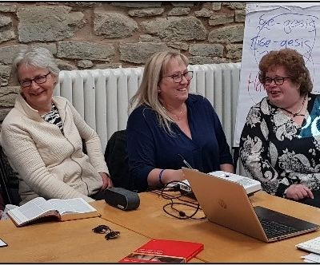

Introduction to Christian Ministry: a new one-year course delivered in Gloucester and Hereford dioceses has attracted 43 students in its first year. It is suited for worship leaders, messy Church or Open the Book leaders, members of local pastoral care teams, and Christians wanting to deepen their understanding of Christian heritage.

enquiries@rcc.ac.uk 01865 874404 www.rcc.ac.uk
Open Day Dates and Booking

